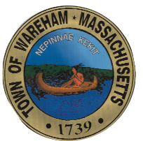
Community and Economic Development Authority

Board Meeting Minutes

6:30 PM, October 20, 2014
TOWN OF WAREHAM Town Hall Room 23
54 Marion Road
Wareham, MA 02571

Present: Robert Brady, Jean Connaughton, Robert Fichtenmayer, Kat Jones, Michael Fitzgerald, and Salvador Pina

Not Present: Rudi Santos, and Stephen Holmes

Guest(s): Paula Hamilton

Call to Order: Chairman Connaughton called the meeting to order at 5:02 PM.

- Board Member Interview – Paula Hamilton
The Board interviewed Ms. Hamilton for a potential candidate to fill a vacant spot on the CEDA Board.

Board Action Taken: Mr. Brady motioned to recommend Ms. Hamilton for a seat on the CEDA Board. Mr. Fichtenmayer seconded the motion. The motion carried 5-0-0.

- FY’15 CDBG Planning
Mr. Pina presented an overview of various projects for the Board to consider for the FY’15 CDBG Application. The Board determined that it would review the information and take up this item at its next meeting.

Board Action Taken: None at this time.

Other Business: None

Adjournment:
Mr. Fichtenmayer motioned to adjourn the meeting. Mr. Brady seconded the motion. The motion carried 5-0-0. The meeting was adjourned at 6:47.

Next Meeting: October 20, 2014

